**Embedded systems lab**

*Project-Title: Parking assistance*

|  |  |  |  |
| --- | --- | --- | --- |
| Document-ID: | | Version: 0.1 |  |
| Project: | Parking assistance | From: Tarek Hamouda | 2017-01-05 |
| State (draft, released, final): | [Status] | Document-owner: | [Type the author name] |
| Classifikation (confidential, internal, public): [Category] | | |  |

Hinweis zu den diversen Dokumentenfelder: Diese sind unter „Properties“ zu pflegen, und zwar:

Projekt-Titel bzw. Projekt: übernimmt den Text vom Feld „Title“

Version: übernimmt den Text vom Feld „Version“ (Untermenü Advanced properties)

Dokument-Eigner: übernimmt den Text vom Feld „Author“

Status: übernimmt den Text vom Feld „Status“

Klassifikation: übernimmt den Text vom Feld „Category“

DOCUMENT VERSION CONTROL:

|  |  |  |  |
| --- | --- | --- | --- |
| Vers. Nr. | Description | Date | Author |
| 0.1 | Initial draft | 2017-05-01 | Tarek Hamouda |
| 0.2 | Connections Diagram | 2017-05-05 | America Ramirez |
|  |  |  |  |
|  |  |  |  |
|  |  |  |  |
|  |  |  |  |

Hinweis zur Vers.no.

Die Nummern unter 0 sind die NTS-internen Versionen während der Erstellung.

Die Version 1.0 ist die erste, die offiziell dem Kunden zugestellt wird.

Normalerweise werden dann die Einträge unter Version 1.0 entfernt.

Contents

Contents 3

1 Management Summary 4

1.1 Objectives and motivation 4

1.2 Project description / abstract 4

1.3 References 4

2 Assumptions/ Limitations 4

3 Solution description 4

3.1 General description 4

3.2 Overview Chart 5

3.2.1 System diagram 5

# Management Summary

## Objectives and motivation

Backing into parking space is stressful. And it is rarely a simple matter to reverse into gap without correcting. Nowadays parking assistance systems are widely used in modern vehicles to facilitate this task for drivers. The proposed device in this document will Measure the distance with an ultra-sonic sensor and uses the buzzer to signal the distance as frequency.

## Project description / abstract

The device will offer the following functionalities:

1. Measuring the distance and the speed through ultrasonic sensor.
2. Issuing buzzer sound through buzzer in respect to the distance and the speed of the moving object (the more the car is close to the object the louder the buzzer sound).

## References

* Arduino UNO

<https://www.arduino.cc/en/main/arduinoBoardUno>

* Ultrasonic Ranging Module HC-SR044

<http://www.micropik.com/PDF/HCSR04.pdf>

# Assumptions/ Limitations

* The sensor has a real time processing, there is no delay to receive the echo signal.

# Solution description

## General description

The ultra-sonic sensor will measure the distance between the moving car and the nearest object. At a certain distance (will be set during the programming phase) the buzzer will issue warning sound in form of frequency, to indicate that we are close to an object. When the distance is too close the frequency rate of the buzzer will increase. The solution also include a power saving strategy (9V battery).

## Overview Chart

### System diagram

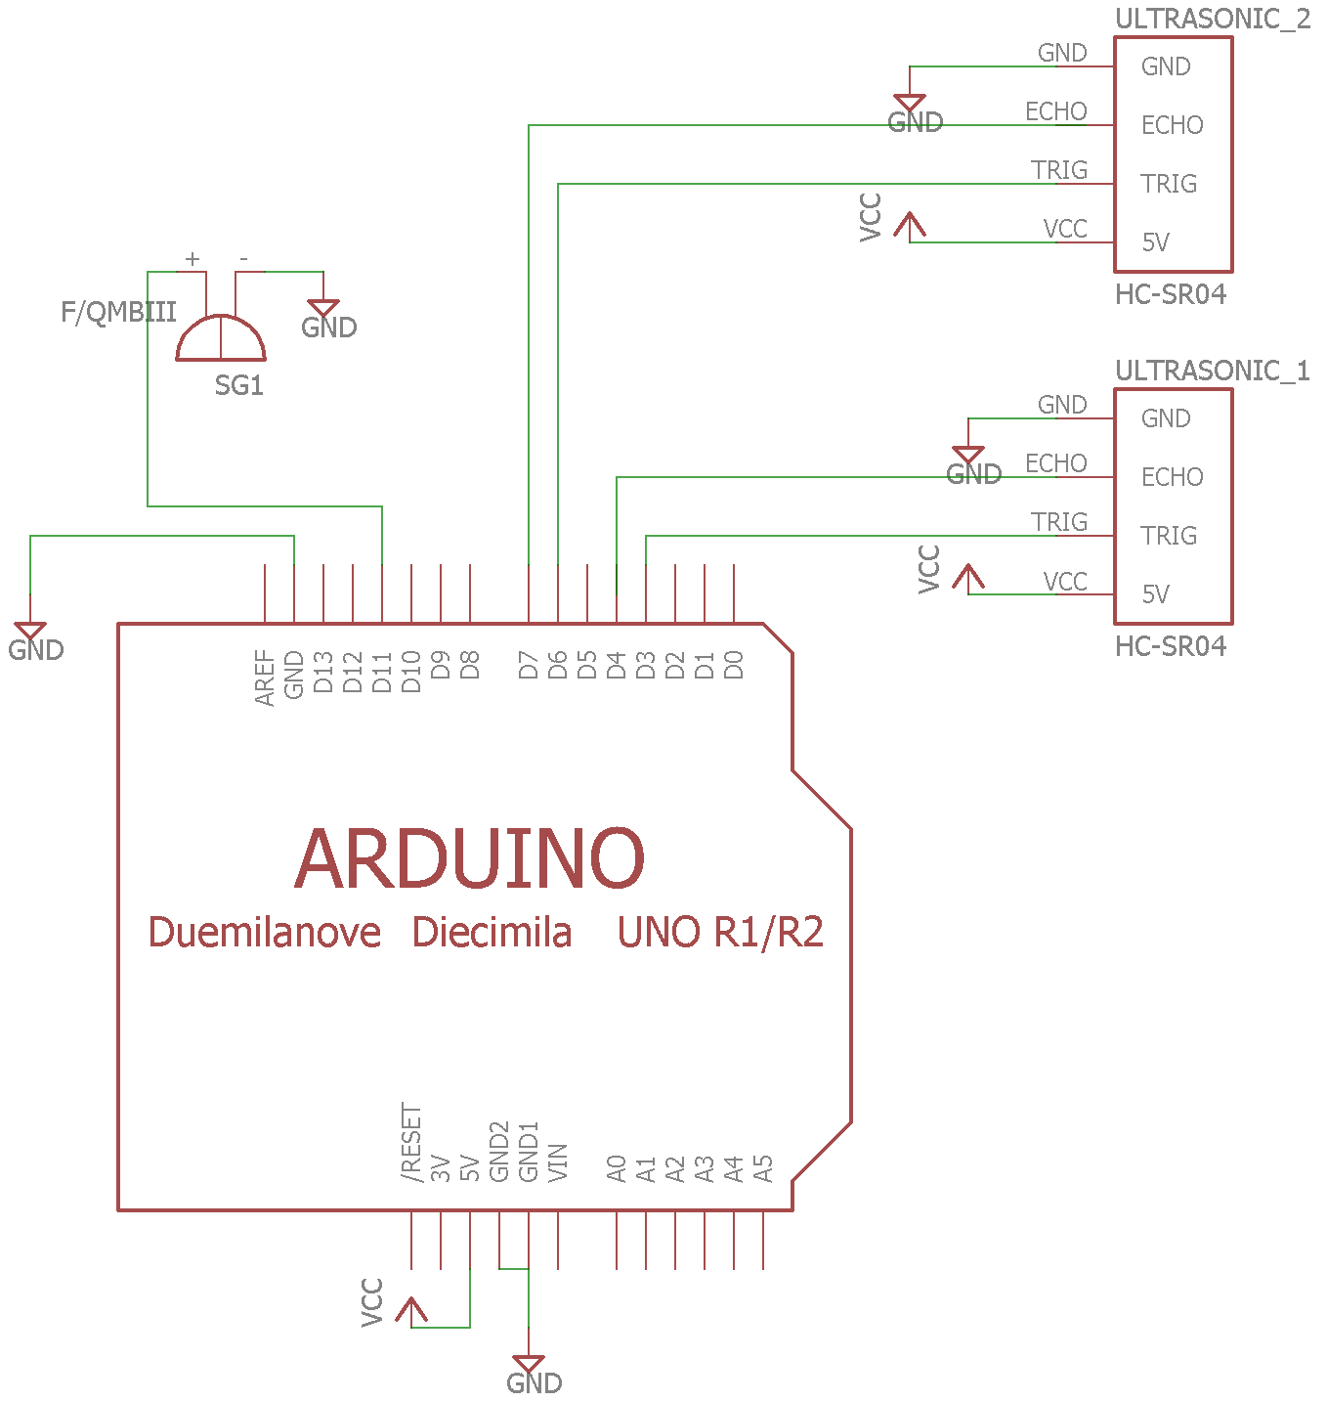

Figure 1: System diagram